Domhnach Mór

**Ad Majorem Dei Gloriam**

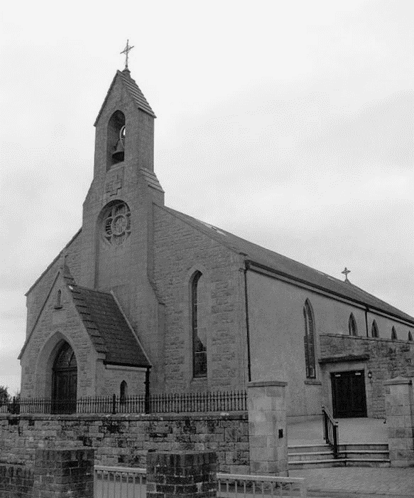 Parish of Donaghmore

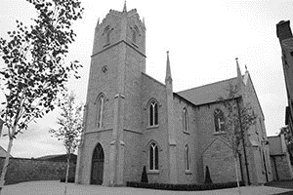*Archdiocese of Armagh*

scroll

A pure heart create for me O God,

Put a steadfast spirit within me.

Psalm 50

|  |  |  |  |  |
| --- | --- | --- | --- | --- |
| **13 October 2024** | ***Prisoners’ Sunday*** | | | **Psalter Week 4** |
| **Twenty-Eighth Sunday in Ordinary Time** | |  | | **Sunday Cycle B** |
| **Twenty-Ninth Week in Ordinary Time** | | |  | **Weekday Cycle 2** |
| * ***Next Sunday, 20 October 2024 Twenty-Ninth Sunday in Ordinary Time***   ***Is 53: 10-11. Ps 32:4-5, 18-28, 22, R/ v 22. Heb 4:14-16. Mk 10:35-45.*** | | | | |

**Pope’s Intentions for October 2024**

**For A Shared Mission**

**We pray that the Church continue to sustain in all ways a Synodal lifestyle, as a sign of co-responsibility, promoting the participation, the communion and the mission shared among priests, religious and lay people.**

|  |  |
| --- | --- |
| **Parish Priest**  Fr Gerard Mc Aleer  Tel: (028) 8776 1327 | **Prayer for this coming week**  **Psalm 28:**  **God’s power seen in the storm**  O give the Lord you sons of God,  give the Lord glory and power;  give the Lord the glory of his name.  Adore the Lord in his holy court.  The Lord’s voice resounding on the waters,  the Lord on the immensity of waters;  the voice of the Lord, full of power,  the voice of the Lord, full of splendour.  The Lord’s voice shattering the cedars,  the Lord shatters the cedars of Lebanon;  he makes Lebanon leap like a calf  and Sirion like a young wild-ox.  (The Lord’s voice flashes flames of fire.)  The Lord’s voice shaking the wilderness,  the Lord shakes the wilderness,  the Lord’s voice rending the oak tree  and stripping the forest bare.  The Lord will give strength to his people,  the Lord will bless his people with peace. |
| **Associate Pastor**  Fr Patrick Breslan PE. AP.  Tel: (028) 8775 8277 |
| **Retired**  Fr Patrick McGuckin, PE. |
| **Sacrament of Baptism**  To be arranged with Fr McAleer.  They usually take place on Saturday at 4.00pm and Sunday at 12.30pm. |
| **The Disappeared**  God our Father send your Holy Spirit to enlighten the minds and hearts of those people who can roll away the stone of sadness and anguish long suffered by the families of The Disappeared… |
| **Please note that all Notices for the Domhnach Mór Bulletin must include a contact number and be left at the Parochial House, Donaghmore by 9.00 pm on Wednesday.** |

**Anniversary Notices in the Domhnach Mór Bulletin**

When requesting an anniversary Mass please write the name of the deceased, the day and date of the anniversary, the chapel and a contact name and number on the **outside** of the envelope and leave in Donaghmore Parochial House or in either sacristy.

**In Memoriam**

*“It is a holy and wholesome thought to pray for the dead” (2 Maccabees 12:46)*

**Recently Deceased**

Cassie Devlin Jimmy Quinn Cathleen Treacy Kathleen Hackett

**

**Anniversaries**

**Weekend Mass Times**

Saturday 6.00pm Donaghmore - Vigil

Sunday 10.00am Galbally

Sunday 11.00am Donaghmore

**Weekday Mass Times**

Donaghmore

Monday – Friday 9.30am

Saturday 10.00am

Galbally

Tuesday – Friday 10.00am

*There is no Friday Evening Mass except for Month’s Mind and 1st Anniversary Masses.*

*Sat 12 Oct*  Jim McQuaid

Lily Loughran

*Sun 13 Oct* Seamus and Susan Rafferty

*Wed 16 Oct* Joseph Hurson

Mary Hurson

*Thur 17 Oct* Johnny Curran

*Sat 19 Oct* Johnny Hetherington

Mary Rose Hetherington

Ann Woods, Winifred Hughes

John Murray, Rita Corry

Brendan Hetherington

*Sun 20 Oct* Anne Drayne

Lizzie & Minnie Quinn

**Gortindarragh Mass Glen Arrangements**

5pm Adoration Galbally Chapel

6pm Rosary Galbally Chapel

Pat Nugent, Annie Nugent,

Hugh Anthony Nugent, Sean Nugent

Veronica & Peter Kelly

Patrick Joe Morris, Patrick Donnelly

***Requiescant in Pace***

|  |  |
| --- | --- |
| **Sunday Collection**  **Thank you for your contribution.** | **Gift Aid**  Use your envelopes and add 25p to every £1 you give.  **Contributing to the Parish by Cheque**   * Dues made payable to Donaghmore Parish Clergy Revenue Account * Any other cheque should be made payable to Donaghmore Parish |

**Accord Marriage Guidance**

Accord (NI) provides a marriage and relationship counselling service for any couple who may be experiencing difficulties or challenges in their relationship. Our professional counselling service is based on client need rather than an ability to pay and we are based in 11 locations across N. Ireland. We try to be as accessible as possible and offer both in-person and online counselling to all, regardless of faith, denomination or none. We specialise in couple counselling, including domestic violence and are also available to individuals in a couple relationship. Accord (NI) counselling can significantly improve the wellbeing of children when their parents seek our help. Contact Accord (NI) at info@accordni.com www.accordni.com Tel: 028 9023 3002.

**Tuesday 15 October – Feast of St Teresa of Ávila**

(1515-82), Contemplative, highly active and practical, established Carmelite convents under a reformed rule, and wrote much on prayer and the spiritual life. Patron of Spain.

**World Mission Sunday – 20 October 2024**

World Mission Sunday is the one Sunday of the year when the entire global Church comes together in support of mission. It is the Holy Father’s annual appeal for spiritual and financial support so that the life-giving work of overseas mission and missionaries can continue.